Technological Institute of the Philippines

938 Aurora Blvd. Cubao, Quezon City

College of Information Technology Education

IT 004– Web Systems and Technologies

Midterm Period

Developing Company Website

|  |  |
| --- | --- |
| Team Name: CookieEaters  Leader: TABADA, BRIAN GERARD G.  MEMBERS:  BUENAVENTURA, ARISTOTLE C.  CABURNAY, RAINE CARLO  CAÑAMO, ETHAN REI S.  MEJOY, JOSEPH ADRIAN | Date: 10/30/2021 |
| Program / Section: | Instructor: Ms. Roxanne A. Pagaduan |
| Assessment Task: Project Part 2: Company Logo; and Designing Homepage with Landing Page | |

**Instructions:**

* Provide screenshots to satisfy the requirements. (note: include screenshot of source code and sample run-time output in every source code and output changes)
* Include your **TEAMNAME** in every screenshot.
* You are required to provide the screenshot of your source code for each file like (.html, .css, .js, .php) and a sample output running in the browser.
* Include a brief description in each screenshot.
* Use appropriate filename in saving your files.
* Save your work as **TeamName_ProjectPart2.DOCX** (Ex. TeamWeb_ProjectPart2.DOCX and .PDF)
* Record your screen while performing the task or create a video explaining your answer by running the web page in a browser. Make sure all members contribute and participate in answering the problems. You can use any tools for collaboration like Team Viewer, Google Meet, etc.
* Save your recorded video in .MP4 format and store it inside your google drive using your T.I.P. email account. Note: use appropriate filenames
* Kindly take note of the deadline for submission.
* This activity will be graded using Rubric for Laboratory Performance in Web Systems and Technologies.

**This activity supports the attainment of Course Intended Learning Outcomes (CILOs):**

1. Distinguish different client-side programming languages and other web GUI technologies.
2. Create and validate documents and generate content by integrating digital libraries.
3. Develop web application and set up web server to support server-side functionality and configuration issues.

**Requirements:**

Using your Approved Topic Proposal, satisfy the following requirements:

1. Collaborate with your partners and satisfy the following:

* Company Name
* Company Background - discuss a brief description of your company.
* Provide different modules included in your project and its descriptions (ex. Log-in Module, User Maintenance, Products, etc.). Also, include all the necessary information needed. (ex. products, descriptions, product pricing, images, audios, videos, etc.) Note: Assign module in each member.

*Note: Acknowledge all your references*

* Design your own company logo (note: save the logo file in appropriate file format)

1. Create a webpage (or homepage) of your company’s website applying bootstrap. Also, include a landing page on your homepage.
2. Initially design the related web pages of your website.
3. Provide the specific contributions of each member. (Note: use the template provided)
4. Acknowledge all your references

**ANSWER:**

**Video Link: *<Paste here the link of the video saved in your google drive. Remove the restrictions of the file for checking purposes>***

**Team Name:** CookieEaters

**Project Title:** Hotel Management System

**Company Name:** Gourmet Hotel

**Company Background**



Gourmet Hotel started during the pandemic. The founders established the company to provide rooms to foreigners or OFWs that arrived in the country. The founders attended the same school and had an idea to start an efficient, top-tier, and budget-free service. As time goes by, guests are welcomed and served with the highest quality of service, and we were able to extend these services across the country. The Gourmet Hotel is located just minutes from the heart of Quezon City. Conveniently situated away from congestion and crowds, we provide you with a refreshing opportunity to experience choices and flexibility like never before. Complimentary high-speed Internet is available throughout our hotel, and keep up your physical routine in our 24-hour fitness center. Our spacious guest rooms provide flexibility in your workspace and comfort in your rest space. Whether traveling for business or pleasure, your stay at the Gourmet Hotel is sure to be more comfortable, productive, and enjoyable than ever before.

**Products / Services**

1. Rooms

***Room Alpha***

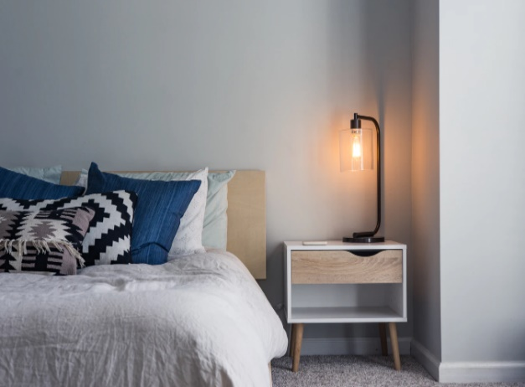

Our smallest bed, with typical setup with built-in desk area. Custom tile and premium fixtures adorn the bathroom. Double doors open directly to main patio. 290 sq ft.  
  
**Room Inclusions:**  
- WiFi and USB ports  
- Bathroom  
- Shower  
- Flatscreen Tv with cable  
  
**Price:** Minimum price within 6000

***Room Bravo***  
  
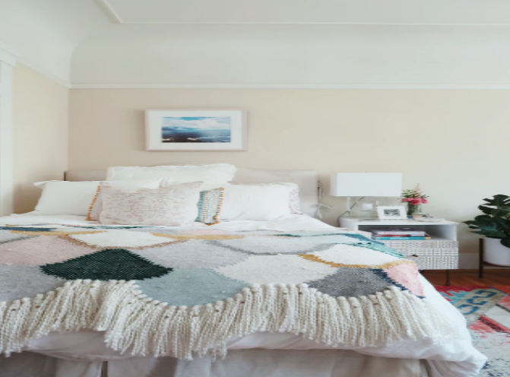

Our average bed, with typical setup with built-in desk area. Custom tile and premium fixtures adorn the bathroom. Double doors open directly to main patio. 350 sq ft.

**Room Inclusions:**  
- WiFi and USB ports  
- Bathroom  
- Shower  
- Bathtub  
- Spa  
- Flatscreen Tv with cable  
  
**Price:** Minimum price within 8000

***Room Charlie***

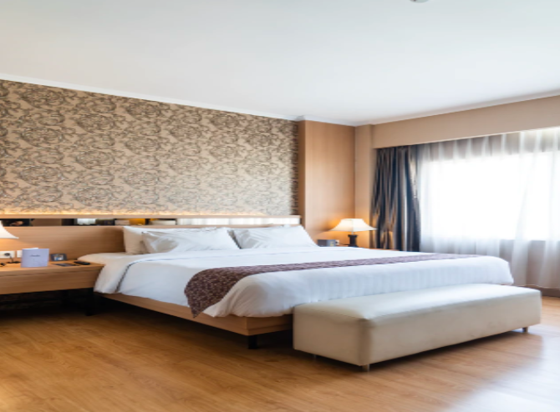

Our large bed, with typical setup with built-in desk area. Custom tile and premium fixtures adorn the bathroom. Double doors open directly to main patio. 450 sq ft.

**Room Inclusions:**  
- WiFi and USB ports  
- Bathroom  
- Shower  
- Bathtub  
- Spa  
- Gym  
- Flatscreen Tv with cable  
  
**Price:** Minimum price within 8000

***Room Delta***

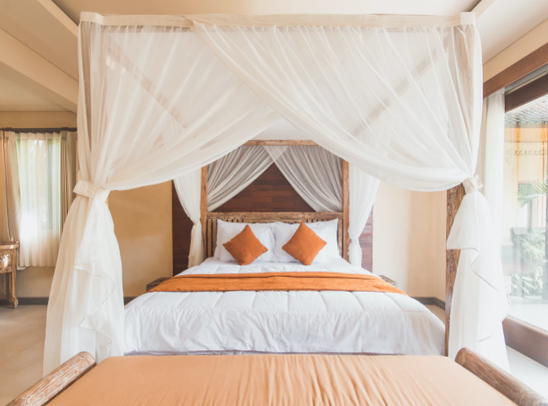

Our biggest bed, with typical setup with built-in desk area. Custom tile and premium fixtures adorn the bathroom. Double doors open directly to main patio. 550 sq ft.

**Room Inclusions:**  
- WiFi and USB ports  
- Bathroom  
- Shower  
- Bathtub  
- Spa  
- Gym  
- Pool  
- Flatscreen Tv with cable  
  
**Price:** Minimum price within 12000

1. Bar

The Gourmet Bar is open to the public daily from 6:00 AM to 11:00 PM. The coffee is freshly roasted and responsibly sourced from Mexican producers and the cocktail offerings reflect our passion for agave-based cocktails. The wine list features a well-curated offering of local natural wines and European low-intervention boutique producers. Salud.

**Wine**

St. Estephe 720php

St. Julien 660php

Verdillac 700php

Medoc 750php

Chateau Coutet 680php

Petit Chapeau 720php

**Cocktail**

Blue Hawaii 140php

Long Island 180php

Margarita 160php

Bacardi 160php

Martini 180php

Cosmopolitan 180php

**Snacks**

Popcorn 50php

Pretzel-Sticks 80php

Peanuts 40php

Chicken-Wings 200php

Sloppy-Joe 180php

Philly-Cheese-Steak 220php

**Beer**

Pale-Lager 160php

Strong-Ale 120php

Wheat-Beer 140php

Brown-Ale 120php

Devastator 140php

1. Private Events

The Gourmet hotel has a special room for the people who need weekend escapes as well as extended stays for a private setting for their events, like parties, weddings, meetings, and reunions that can fill up to 150 guests.

Meetings

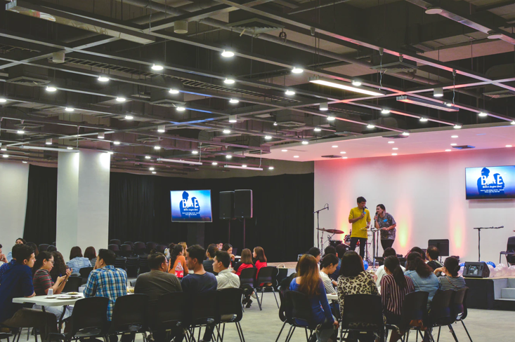

Weddings

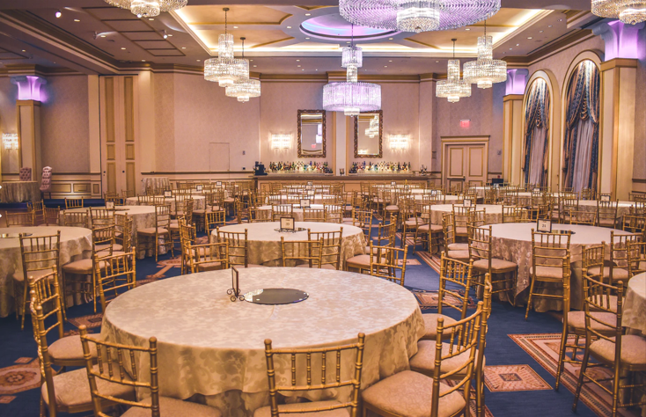

1. Spa and Gym  
   <UNFINISHED>

**References:**

<https://www.w3schools.com/php/>

**Sample Output:**

**Web Page 1: Homepage**

<provide the source code and screenshot of sample homepage running in the web browser>

**Source Code:**

<provide the source code>

**Output:**

<sample homepage running in the web browser>

**Web Page 2: Products / Services**

<Provide the source code and screenshot of sample output running in the web browser>

**Source Code:**

**Output:**

**Web Page 3:**

<Provide the source code and screenshot of sample output running in the web browser>

**Source Code:**

**Output:**

**Web Page 4:**

<Provide the source code and screenshot of sample output running in the web browser>

**Source Code:**

**Output:**

**Summary of Assigned Tasks**

|  |  |  |  |
| --- | --- | --- | --- |
| **Name (SN, FN, MI.)** | **Picture (1x1 formal attire)** | **Detailed Contributions/Assigned Tasks:** | **Average Score (Rate 1 to 10)**  **Note: 10 is the highest** |
| Leader's Name: |  |  |  |
| Member 1: |  |  |  |
| Member 2: |  |  |  |
| Member 3: |  |  |  |
| Member 4: |  |  |  |
| Member 5: |  |  |  |
| Member 6: |  |  |  |